European Rangers` training seminar
Romania
Hunedoara, 17th - 21st September 2007

Introduction

The International Rangers’ Federation and Romanian Rangers Association organize, in 2007, first European Rangers` training seminar, which will be hosted by The Retezat National Park, Hunedoara – Romania.

The goals of the seminar are:
- to share experiences and to learn from each other
- to inspire and gather motivation in the protection of nature
- to offer the opportunity to experience the natural and cultural heritage of Romania

Location

Hunedoara City

The first written evidence of the city lasts from 1265 – the town is named
Hungnod, meaning a hub for leather tanning and wool processing. The city of Hunedoara became an important iron extracting and processing center of Transylvania. "Corpus Inscriptiorum Latinorum" refers to a local inhabitant as "natas ibi, ubi ferum nascitur", that is, "born where the iron was born". The swords and spears, made in the 14th and 15th centuries in the iron foundries and works, were famous for their stiffness in a period of intense fighting with the Ottoman Turks.
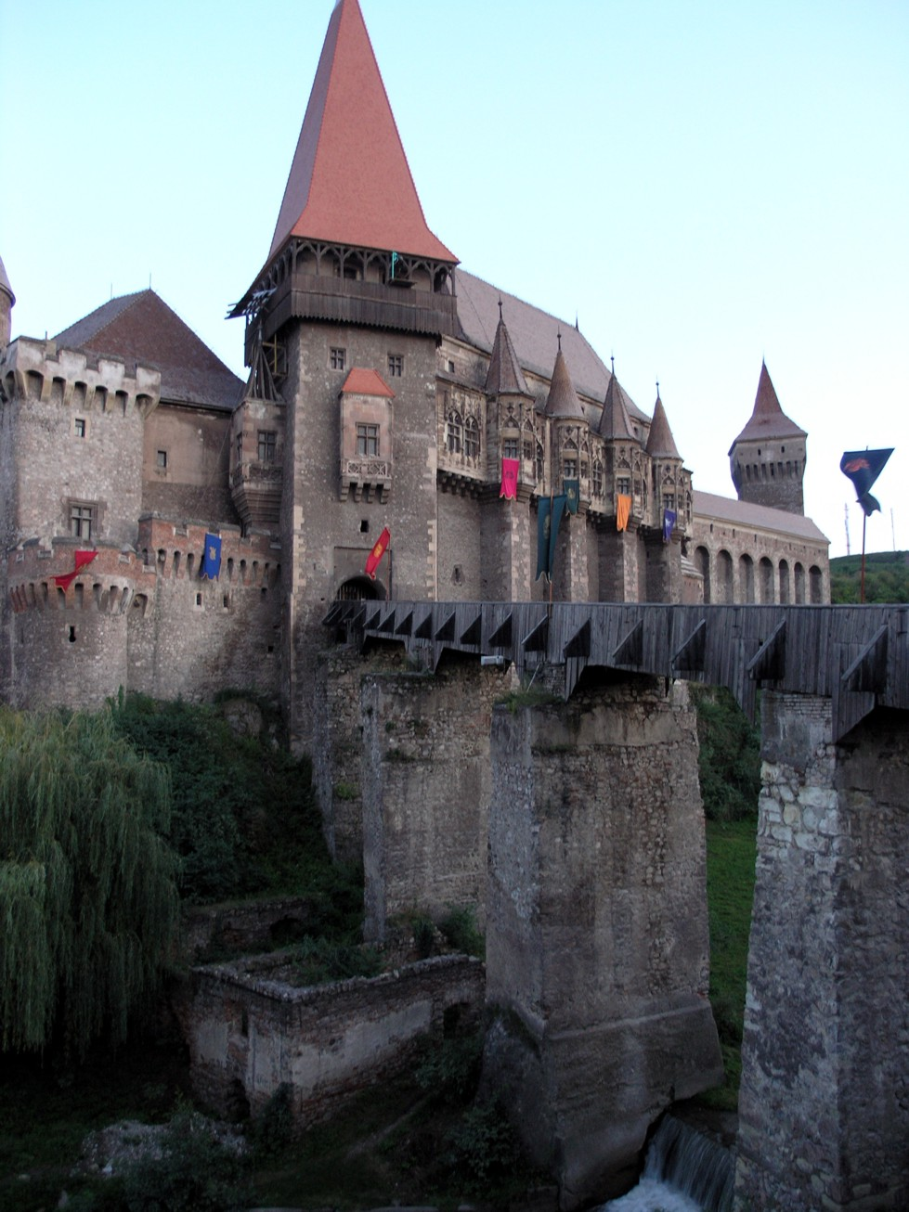
The city of Hunedoara has the most important Gothic-Style secular building in Transylvania: Corvin`s Castle, which is closely connected with the Corvin family.
The impressive size and architectural beauty sets it among the most precious monuments of mediaeval art, subsequent developments mixing the Gothic style with those of Renaissance and Baroque. It has an impressive draw-bridge, countless towers, a number of internal yards and two large halls, "The Knight Hall" and "The Diet Hall", for the latter housed the diet of Transylvania for a very short period.
Besides the Romanian population, there are also ethnic Hungarians and Germans living in Hunedoara. The city holds many green gardens and old trees flank the streets. The castle has been turned into a museum, following recent reconstruction. A large dam, with tourist facilities, is located a few kilometres away from the city, up in the mountains. A big, nice hotel, recently renovated, lies in the city center.
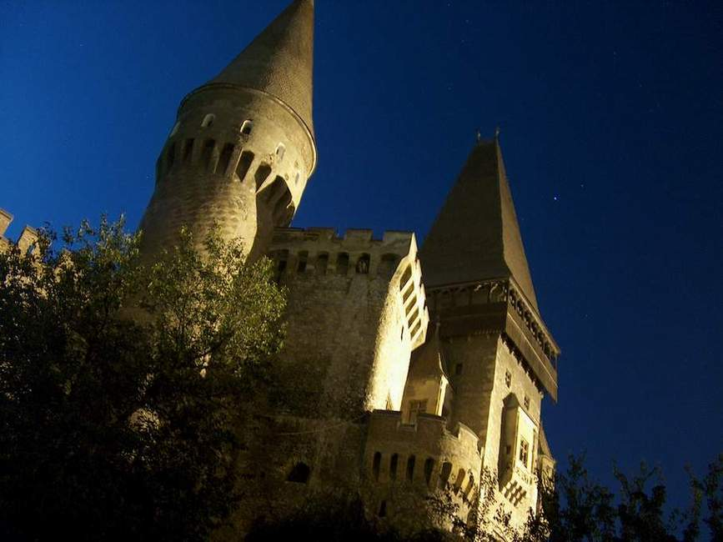
During the 20th century, Hunedoara increased its population to 86,000 inhabitants. The city used to contain the second largest steel works in Romania, but this has now closed down. However, the economy of the city is now benefiting from new investment.

Retezat National Park

It is the first national park of Romania, created in 1935 to preserve the beauty of the mountains and to protect rare and endemic plants. Retezat National Park is located in the Southern Romanian Carpathians and cover 38138 Ha in surface.
Their altitude ranges from 794m to 2509m at the highest peak, and one can find here beautiful glacial lakes, mountain streams, ravines and gorges.
Retezat NP Scientific Reserve
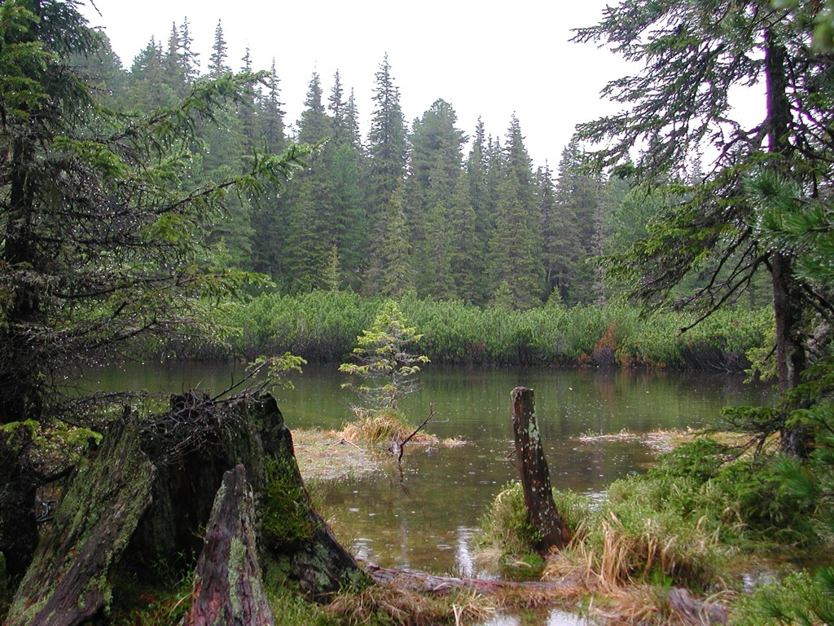
More than 1/3 of the Romanian flora can be found in the Retezat Mountains.
High meadows create a haven for rare alpine flora. In the mountain area, long steep slopes are covered with different types of forest, especially beech, spruce and fir, with birch and rowan as pioneer species. At the sub-alpine level, slopes shaped by ice are often protected by dwarf pine. The forest line reaches 1900 m with some Spruce adapted to the harsh climate. Arola pine (Pinus Cembra) in the dwarf pine cover offer shelter and food to birds.
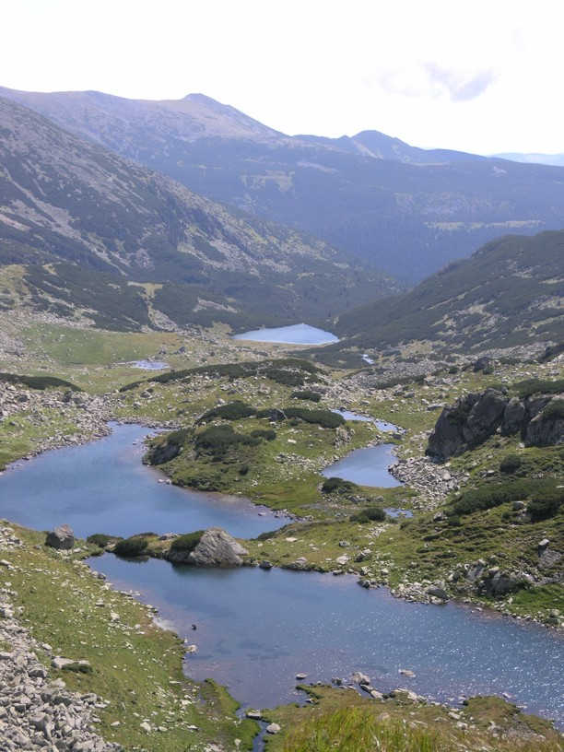
The fauna is wide and varied, so one might come across the chamois, wolf, fox, wildcat, lynx, bear, wild boar, deer, rabbits, squirrels, weasel, badger, beech-marten, otter, marmots, golden eagle, wild cock, hazel-grouse, rock lizards, salamander, and adder.

Program of the event

Monday 17th September 2007
Hunedoara
Arrival day and opening ceremony

Arrival to Deva rail-station (the shortest way is to land in Budapest Airport and then take the train to Deva), transfer by bus to Hunedoara, accommodation in Rusca Hotel.
For the people from Eastern Europe a solution could be to use private cars (see the map).

12.00 – 17.00 Registration and accommodation of arriving participants
18.00 – The official opening and welcome
19.00 – Dinner

Tuesday, Thursday and Wednesday 18th-20th September
Retezat National Park
Field training seminar

The participants will be split in 3 working groups; each group will attend each topic of the seminar. Transfer by bus from Hunedoara to the three starting points of the Park trails (Rausor, Gura-Zlata, Poiana Pelegii).
07.30 – 08.30 Breakfast
08.30 Departure of the participants from the hotel
10.00 Field training seminar, Retezat National Park
During the field trip, the participants will be offered snacks and water.
18.30 Arrival of the participants at the hotel
20.00 Dinner

Working topics

- Education and interpretation
Educational trail Rausor - Lolaia Ridge, Retezat NP
- Management and biodiversity conservation
Field trip to Gemenele Scientific Reserve – first IUCN category)
- Management of tourist activities
Field trip in the core area of Retezat NP, Lapusnicu Valley, Poiana Pelegii, Bucura Lake.

Education and interpretation

The topic will be discussed during the trip on the educational trail Rausor – Lolaia Ridge. The goal of the educational trail is to describe the biodiversity of the park and it is addressed to different categories of tourists.
Presentations are made by means of informative panels and flyers.
During the trip the different types of site interpretation in various European parks will be discussed.
On our way back, we will continue to debate on the topic in the Ostrovel Visitors’ Center.

Management and biodiversity conservation

The aims of the topic are exchanging information and different approaches in biodiversity monitoring, the problems faced by rangers from all over Europe, particularly related to the management of biodiversity.
The trail is placed in the most untouched area of the park, Gemenele Scientific Reserve, Gura Zlata - Gemenele Romanian Academy Lab –Gemenele Lake.

Management of tourist activities

For this topic we chose the fallowing trail: Rau Mare Valley – Lapusnicu Mare Valley – Poiana Pelegii – Bucura Lake.
This is one of the most popular trails traveled by the tourists, with a large number of people who use the camping places. Here we encounter most of the problems in applying the park regulations, environmental legislation and the management of tourist activities.
Different models of marking and maintenance of the tourist trails will also be discussed.

Friday 21st September 2007
Hunedoara
Conferences and discussions

08.30-09.30 Breakfast
10.30-12.30 Meeting in the conference room of the hotel for discussions related with European rangers’ issues, the relations between IRF and other institutions and future activities.
11.30 Coffee break
13.00-14.00 Lunch
14.30-15.00 Transfer of the participants to the conference room of the Hunedoara Technical University
15.15 The opening of the conference
15.20 Guest speakers from: the Romanian Ministry of the Environment, Europarc, PanParks, The Romanian National Forest Administration
16.00 Romanian premiere of international rangers documentary, “The thin green line” by Sean Wilmore, Park Ranger from Warringine Park - Victoria, Australia
17.30 Press Conference
18.00 Transfer to the Corvins’ Castle
18.15 Visit of the castle
20.00 Transfer to the hotel
20.30 Closing of the seminar and Dinner

Saturday 22nd September 2007

Departure or start of post-seminar tours
Option 1 Retezat National Park
Option 2 Piatra Craiului National Park
Option 3 Apuseni Natural Park
Option 4 Danube Delta Biosphere Reserve

Since all of the activities will take place in the outdoors, minimal hiking equipment is needed: hiking boots, backpack, waterproof jacket and sunglasses.
For the conference day, the official uniform is required.

The costs of the seminar - including accommodation, meals and transportation during the seminar:
Double room: 285 euro/person.
Single room: 335 euro/person.
Suite, double bed: 360 euro/person.

Sign up for options required until 15th June 2007.
Contact: rangers_training@retezat.ro
or hombre@yahoo.com
or mgligan@yahoo.com

Tel: +40 724302875 Florin Halastauan - Ranger Retezat National Park
+40 726184125 Alin Ivascu - Ranger Retezat National Park
+40 744782924 Mihai Gligan – Romanian Rangers Association
Fax: +40 254779969 int. 313

